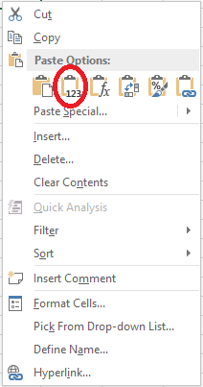This document will explain the steps involved with creating a treemap or sunburst chart (both are new to 2016) in Excel 2016 to visualize the data created from the script. Use the Excel Template spreadsheet that is located with the script as it utilizes PowerQuery to pull in the data from the csv file that gets created when the script is run.

1. After running the script and data is populated into the spreadsheet, you should see a couple of tabs. The PivotTable contains the data in a hierarchy structure. You will need to copy this data and paste into a separate workbook tab (Copied Values). When you paste the data, right click and under “Paste Options” choose Values. (Image circled in red)
2. With this new tab you can create charts to visualize the data. With Excel 2016 there are several new charts that provide a great visualization of disk space utilization. To create a chart from the data, highlight the columns by placing your mouse on B and clicking and holding until you’ve moved the cursor to the last column. Once all rows are highlighted release the mouse.

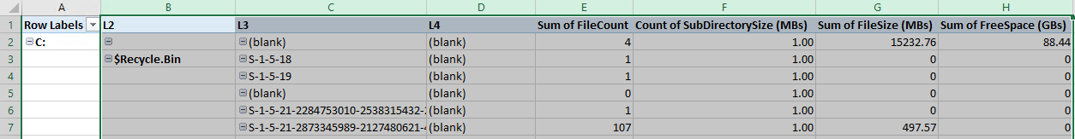

1. At the top of Excel you should see a navigation menu that includes: File, Home, Insert, Page Layout, etc. Select the Insert tab and new options will be displayed.

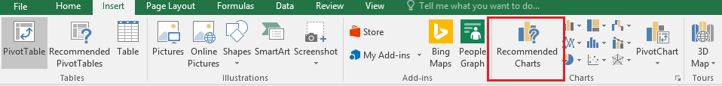

1. 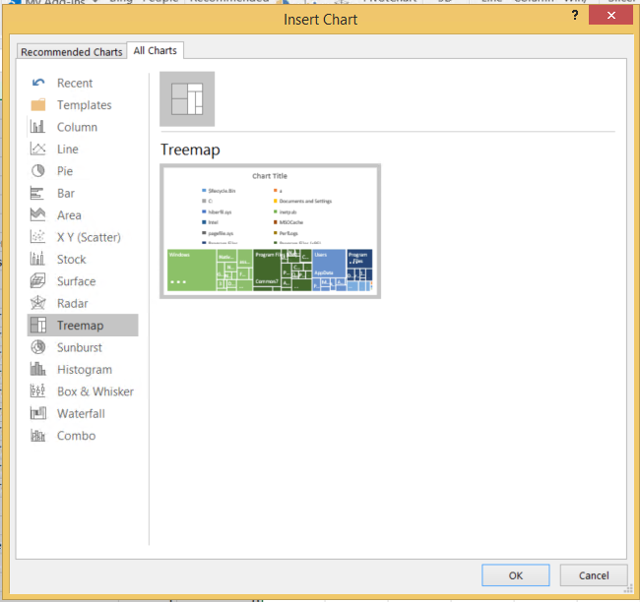Click on Recommended Charts (image above) and a new window will be displayed. Within this window click the All Charts tab to open a list of available charts.
2. The 2 charts that are recommended (and are new to 2016) are the Treemap and Sunburst charts. Select either one of these charts and click Ok.
3. This will insert your chart using the highlighted data which will create visualization of diskspace utilization.

